**The Tragedy of Flight: A Comprehensive crash analysis**

**PROJECT BASED EXPERIMENTAL LEARNING PROGRAM**

.

DONE BY

SIVASUBRAMANIAN..B

DHANA RAMJITH

BASKAR.E

GANAPRAKASAM.G

HARIDASS.P.K.P

INTRODUCTION:

An airplane crash analysis is a detailed investigation into the causes of an aviation accident. The goal of an airplane crash analysis is to identify any factors that contributed to the accident, with the ultimate goal of improving safety and preventing future accidents. The process of conducting an airplane crash analysis typically involves the collection and analysis of a wide range of data, including information about the aircraft and its systems, the operators, and any other relevant factors. This data is typically collected from Kaggle. Once the data has been collected, it is analysed through tableau, to identify any potential causes of the accident. The results of an airplane crash analysis are typically published in a report, which may include recommendations for improving safety and preventing similar accidentsin the future. These recommendations may be implemented by the relevant authorities or industry organizations.

PURPOSE:

Main purpose of the project is to avoid the similar way of accidents in flights and how overcome it.

PROBLEM DEFINITION & DESIGN THINKING :

**Define Problem / Problem Understanding**

@ EMPATHY MAPPING:

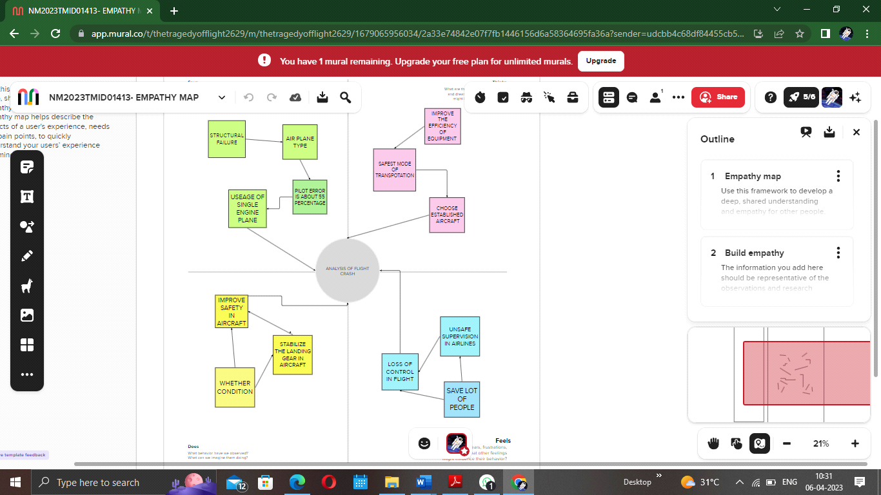/

@ BRAINSTROMING: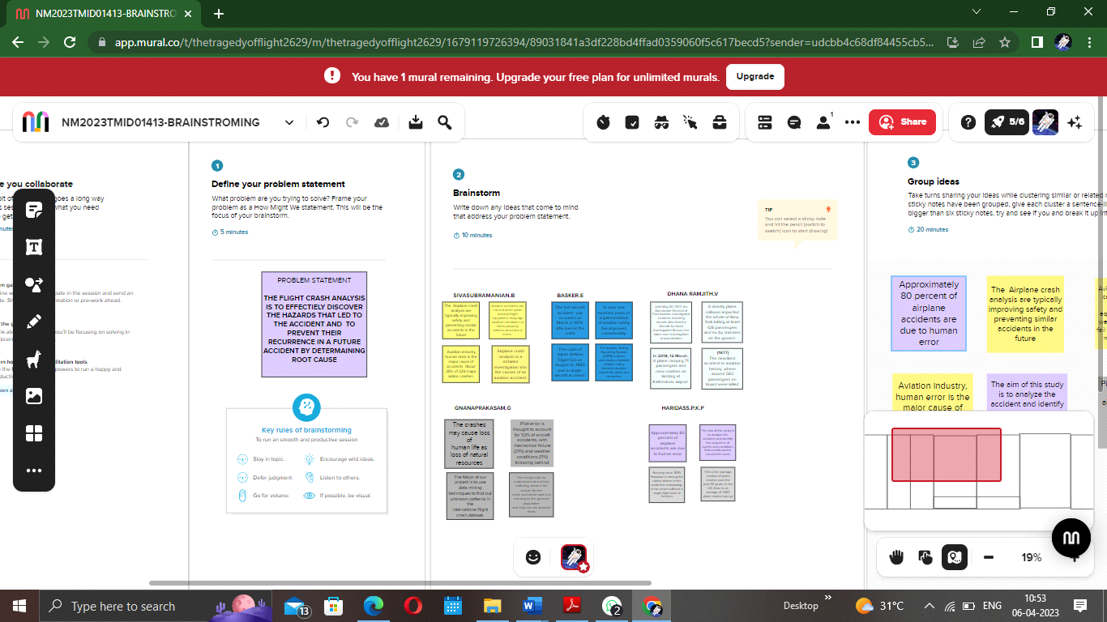

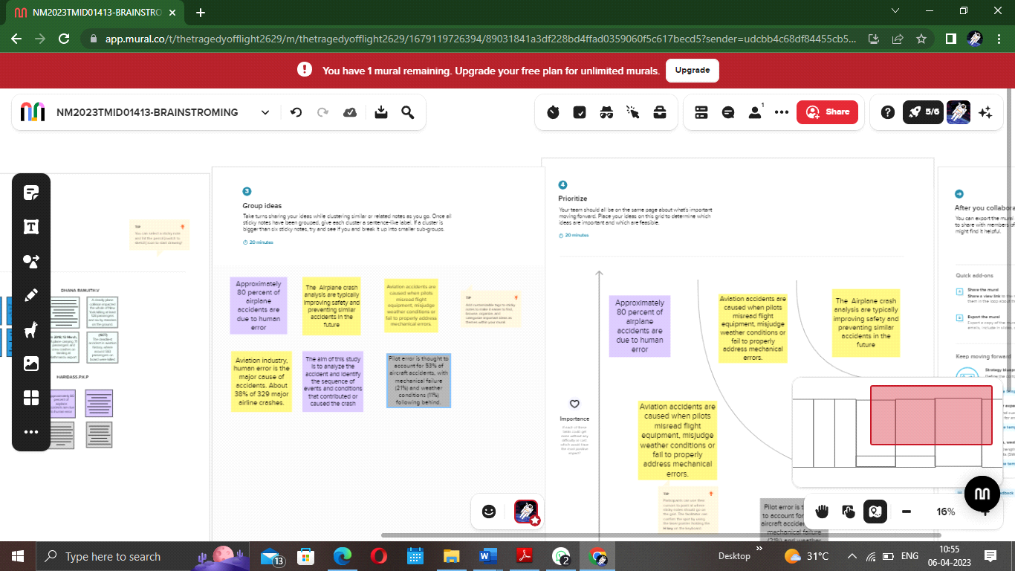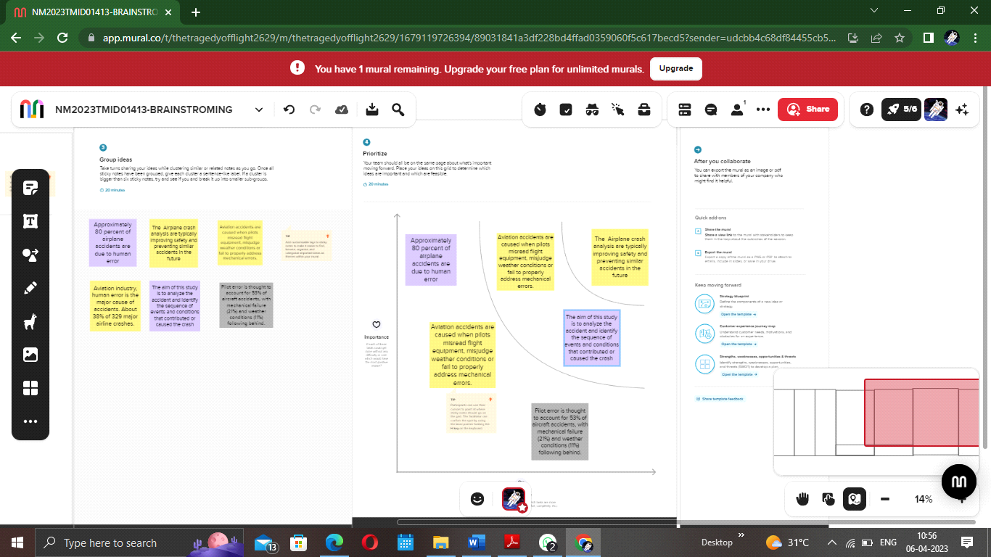

**Data Collection & Extraction from Database :**

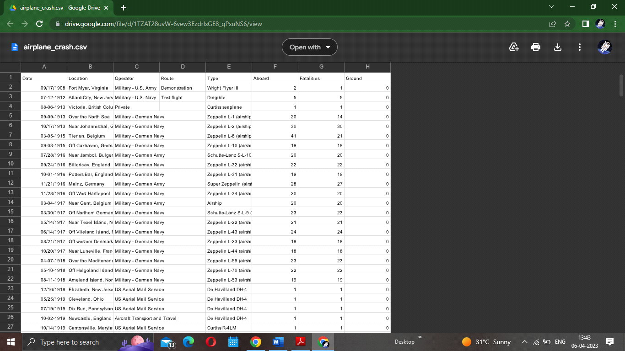

**Storing Data in DB & Perform SQL Operations:**

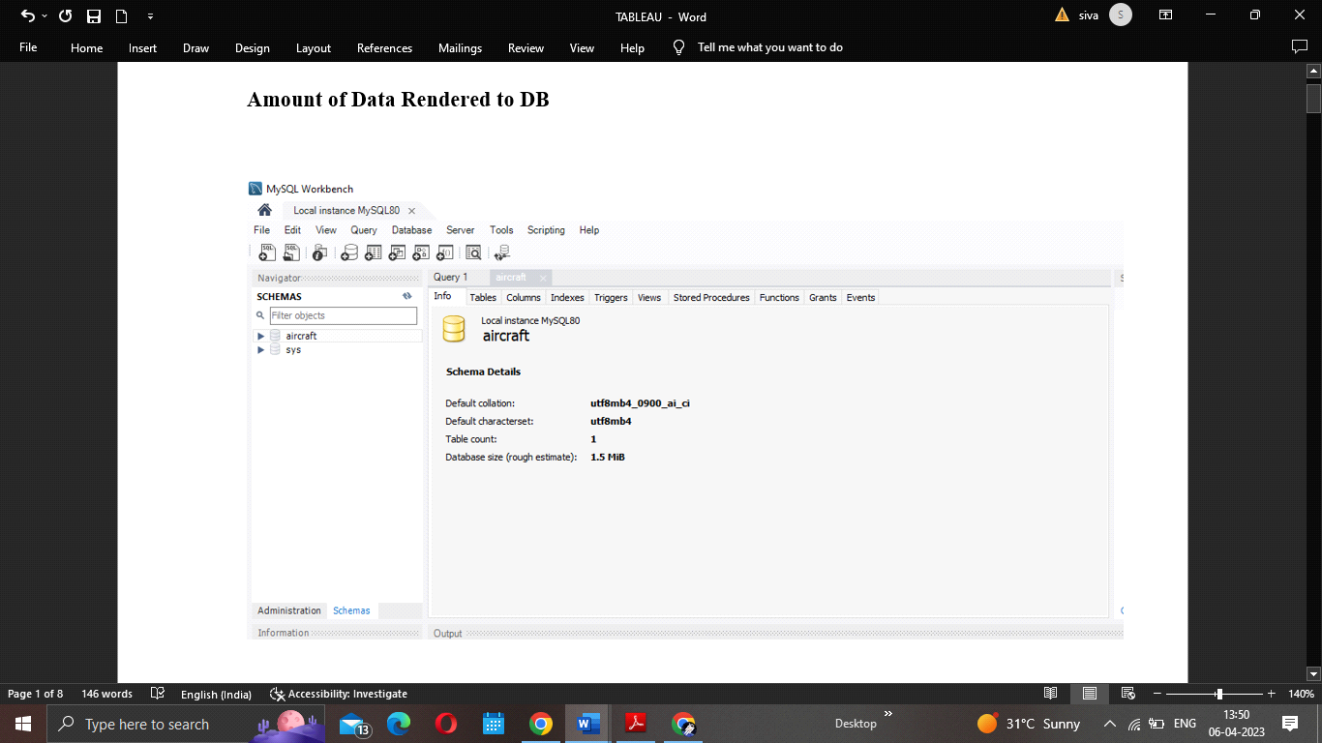

**Connect DB with Tableau:**

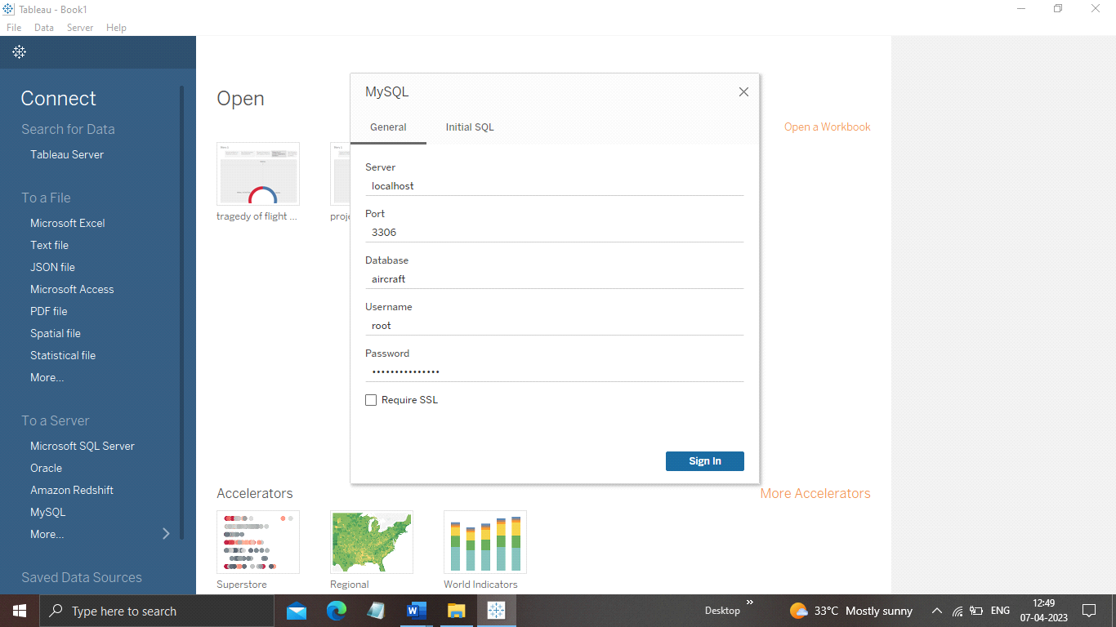

RESULT:

**Data Preparation**

**Prepare the Data for Visualization**

Preparing the data for visualization involves cleaning the data to remove irrelevant or missingdata, transforming the data into a format that can be easily visualized, exploring the data toidentify patterns and trends, filtering the data to focus on specific subsets of data, preparingthe data for visualization software, and ensuring the data is accurate and complete. Thisprocess helps to make the data easily understandable and ready for creating visualizations togain insights into the performance and efficiency.

Data Visualization:

**No of Visualizations/ Graphs**

1. Comparing Aboard vs Fatalities vs Ground

2. Max accidents based on years

3. Accidents happened in 1972 (MAX ACCIDENTS) based on months

4. Highest No. of accident happened by Operators

5. Top 10 locations which had more accidents

6. Top 5 flights which have max accident history

7. Accidents based on regions

**Comparing Aboard vs Fatalities vs Ground:**

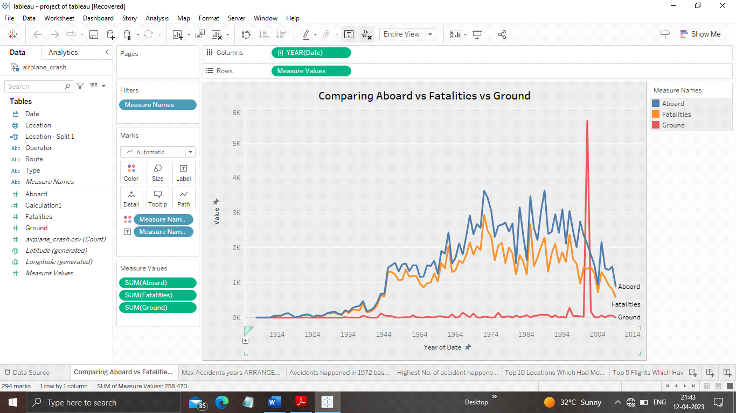

Max accidents based on years:

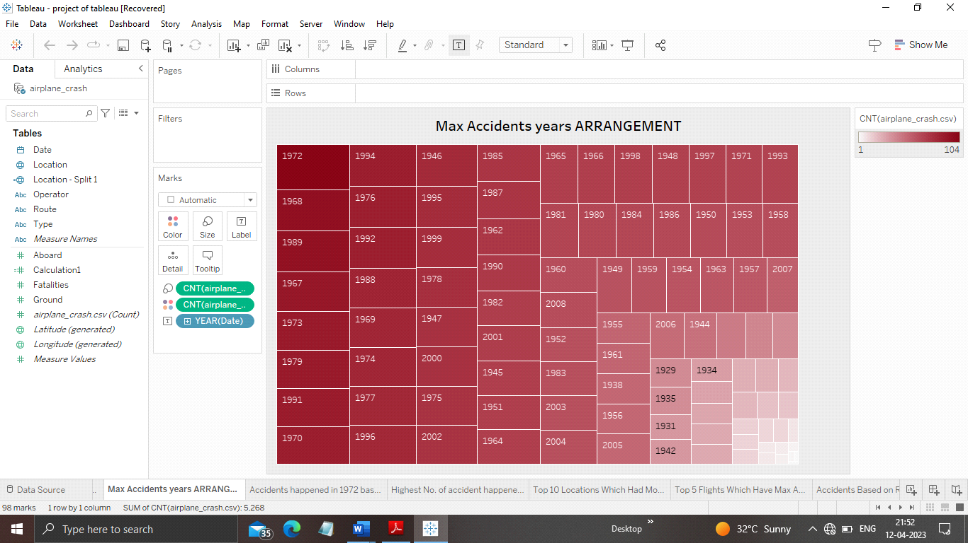

Accidents happened in 1972 (MAX ACCIDENTS) based on months:

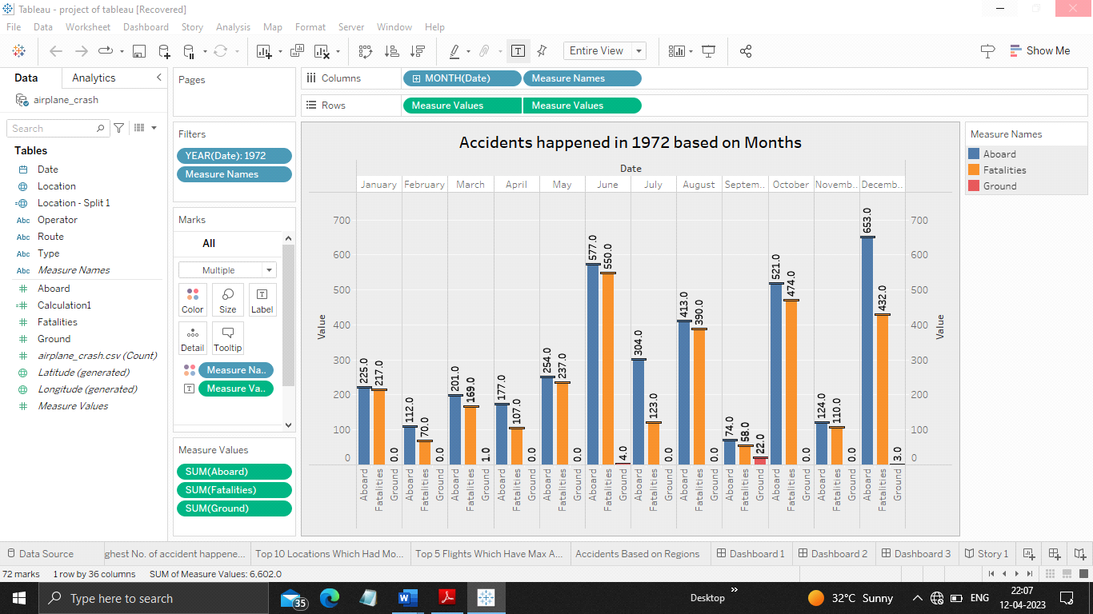

Highest No. of accident happened by Operators:

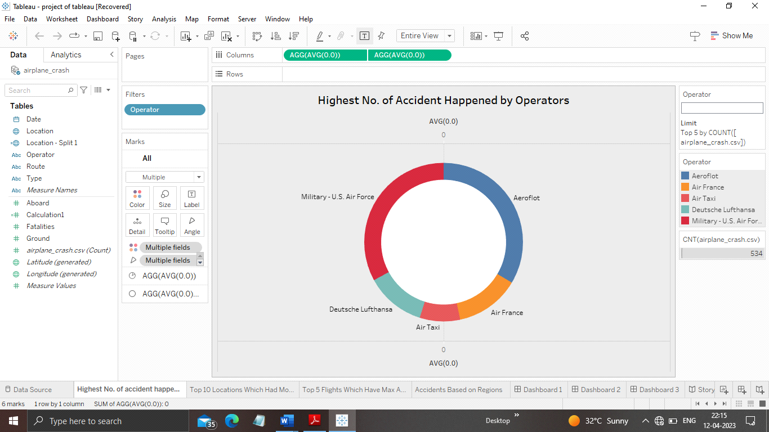

Top 10 locations which had more accidents:

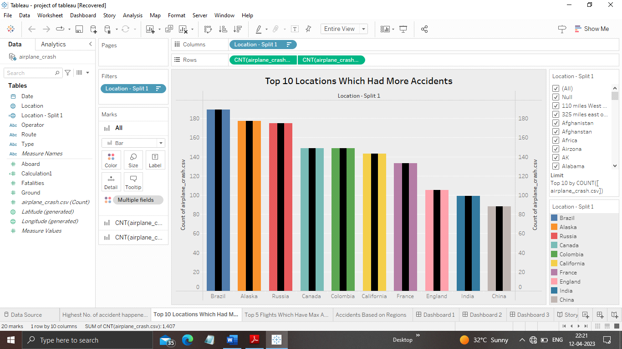

Top 5 flights which have max accident history:

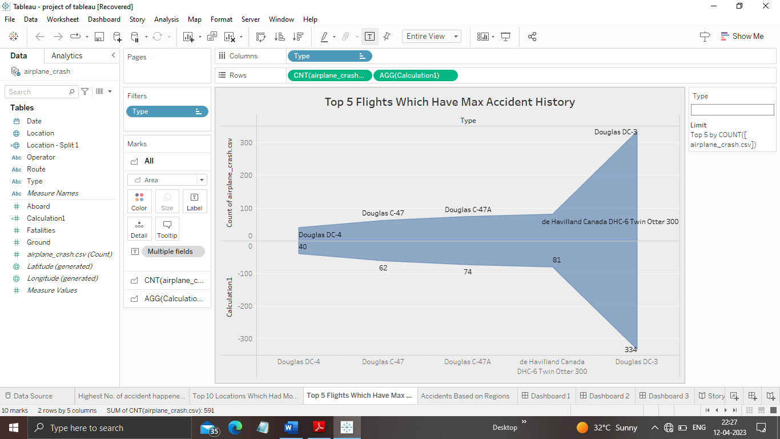

Accidents based on regions:

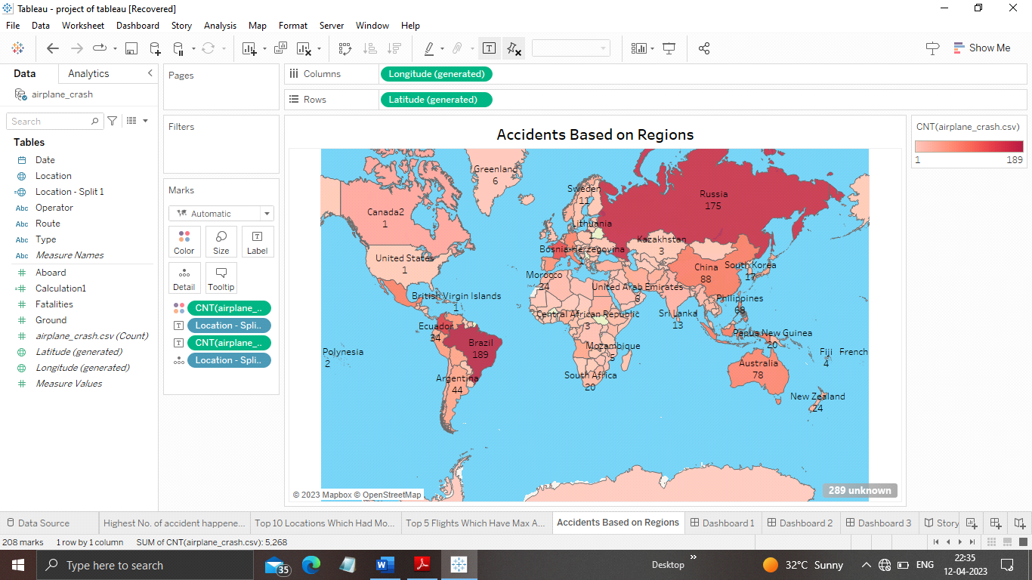

DASHBOARD:

Dashboard is the collection of activity sheet .this gives the quick revise about the project.

DASHBOARD:1

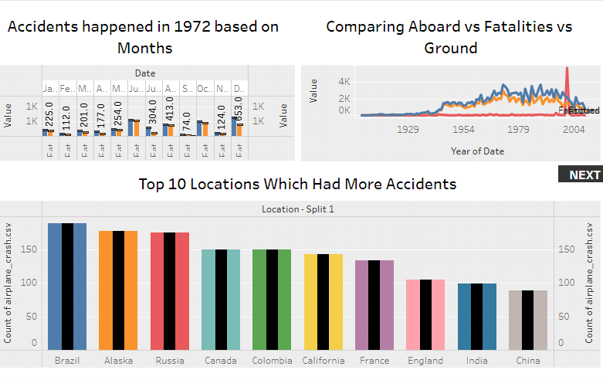

DASHBOARD:2

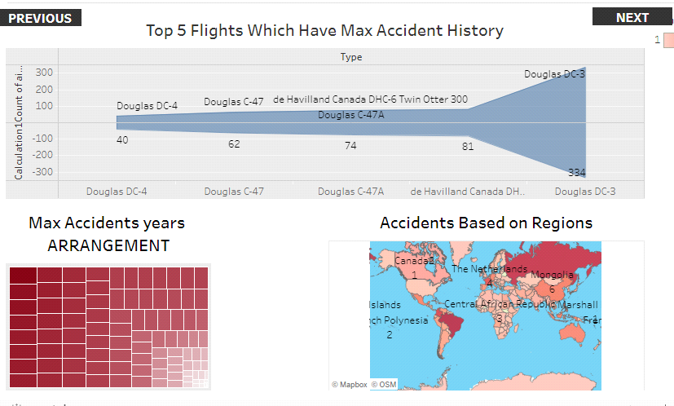

DASHBOARD:3

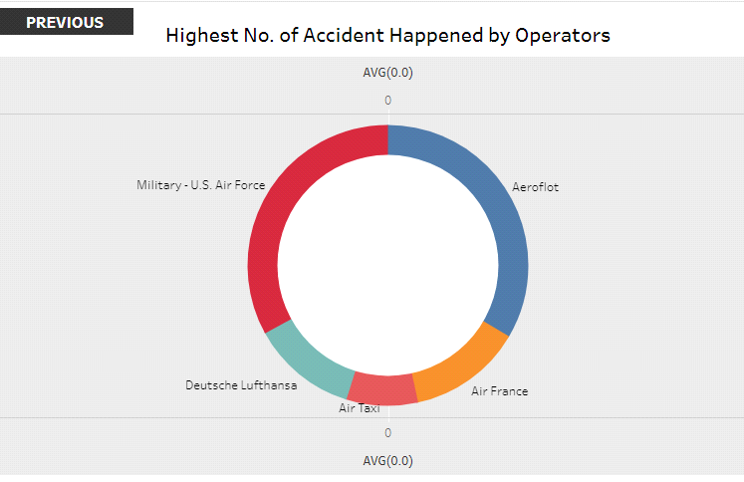

STORY:

Story is the collection of dashboard that we performed in a project.

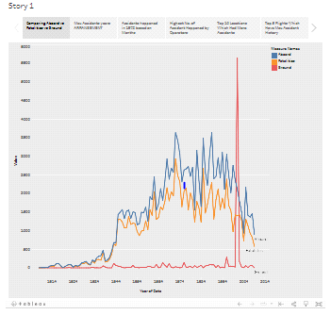

Utilization of Data Filters:

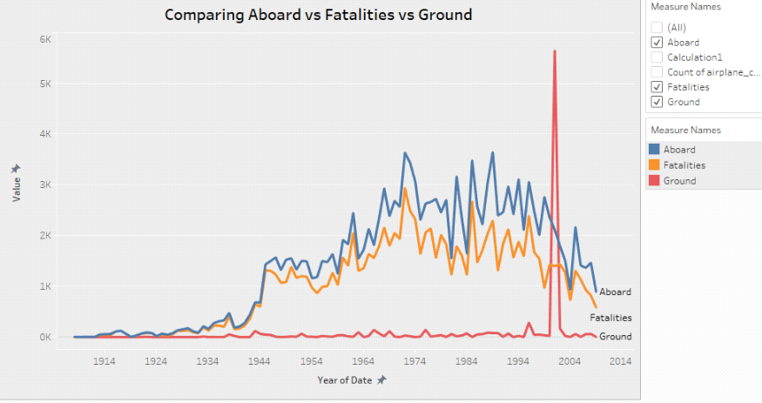

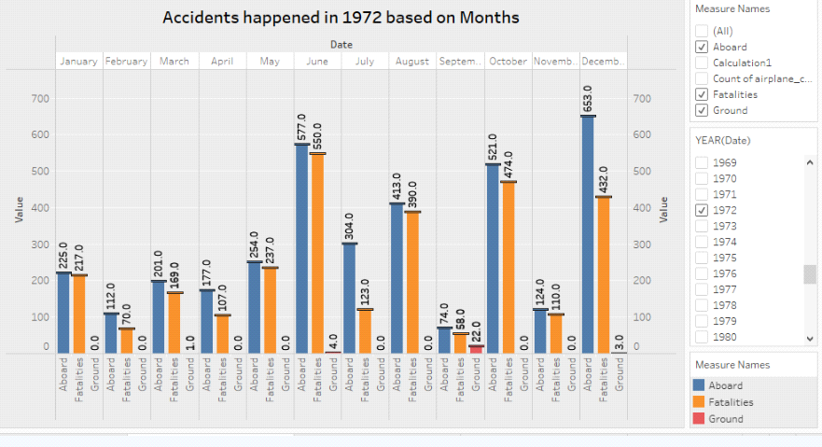

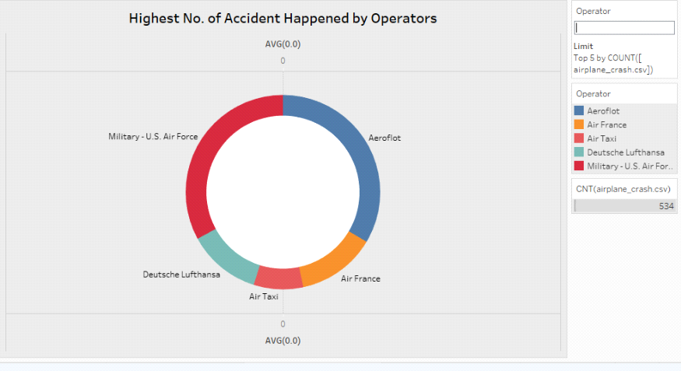

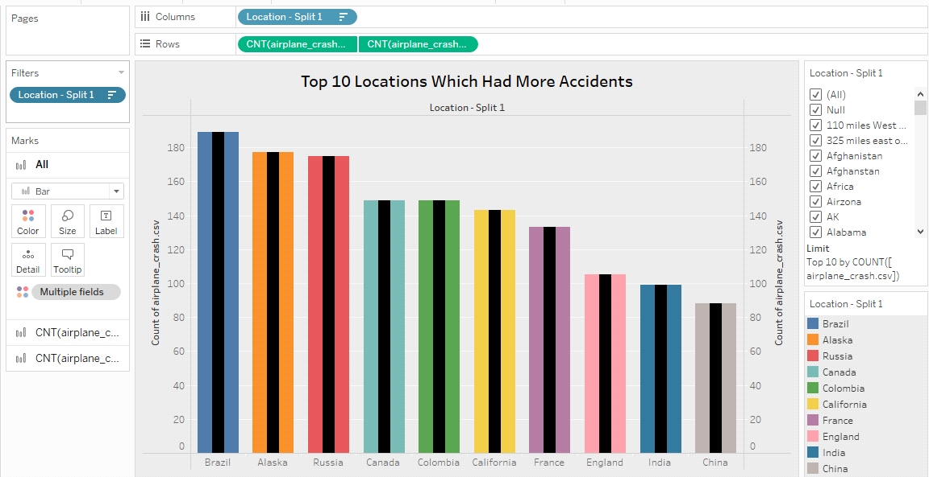

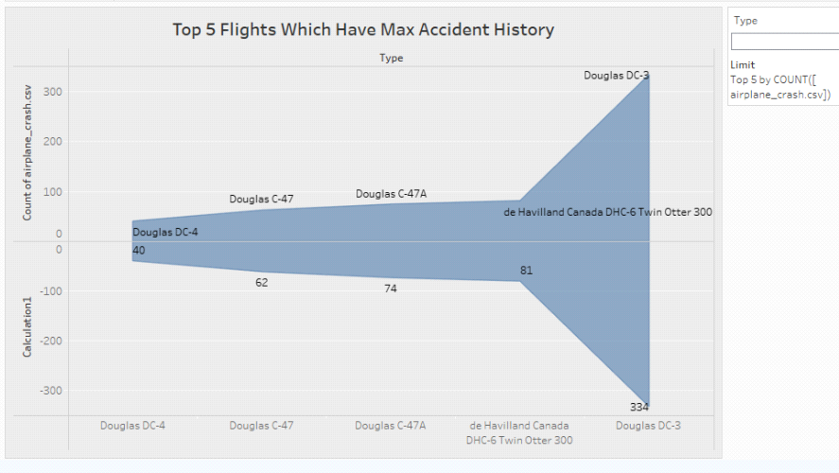

ADVANTAGES:

They **provide a reminder of possible hazards**. Reporting them provides a way to monitor potential problems and root causes as they recur. The documentation of these problems and root causes increases the likelihood that repeating failures will be noticed and corrected before they develop into more serious incidents. **To effectively discover the hazards that led to the accident and to prevent their recurrence in a future accident or incident**.

DISADVANTAGES :

This analysis does not give a clear idea about how the flight crash occur and does not give any progressive.

CONCLUSION :

This study is focused on an airplane crash case to analyze and identity the accident contibuting factors.

FUTURE SCOPE:

This analysis useful to avoid the similar way of accidents and where the majorly accident occur and their location . This project give the clear idea about flight crash and visualize the trend on it.

APPENDIX :

SOURCE CODE:

<!DOCTYPE html>

<html lang="en">

<head>

<meta charset="utf-8">

<meta content="width=device-width, initial-scale=1.0" name="viewport">

<title>FLIGHT CRASH ANALYSIS</title>

<meta content="" name="description">

<meta content="" name="keywords">

<!-- Favicons -->

<link href="assets/img/favicon.png" rel="icon">

<link href="assets/img/apple-touch-icon.png" rel="apple-touch-icon">

<!-- Google Fonts -->

<link href="https://fonts.googleapis.com/css?family=Open+Sans:300,300i,400,400i,600,600i,700,700i|Jost:300,300i,400,400i,500,500i,600,600i,700,700i|Poppins:300,300i,400,400i,500,500i,600,600i,700,700i" rel="stylesheet">

<!-- Vendor CSS Files -->

<link href="assets/vendor/aos/aos.css" rel="stylesheet">

<link href="assets/vendor/bootstrap/css/bootstrap.min.css" rel="stylesheet">

<link href="assets/vendor/bootstrap-icons/bootstrap-icons.css" rel="stylesheet">

<link href="assets/vendor/boxicons/css/boxicons.min.css" rel="stylesheet">

<link href="assets/vendor/glightbox/css/glightbox.min.css" rel="stylesheet">

<link href="assets/vendor/remixicon/remixicon.css" rel="stylesheet">

<link href="assets/vendor/swiper/swiper-bundle.min.css" rel="stylesheet">

<!-- Template Main CSS File -->

<link href="assets/css/style.css" rel="stylesheet">

<!-- =======================================================

* Template Name: Arsha

* Updated: Mar 10 2023 with Bootstrap v5.2.3

* Template URL: <https://bootstrapmade.com/arsha-free-bootstrap-html-template-corporate/>

* Author: BootstrapMade.com

* License: <https://bootstrapmade.com/license/>

======================================================== -->

</head>

<body>

<!-- ======= Header ======= -->

<header id="header" class="fixed-top ">

<div class="container d-flex align-items-center">

<h1 class="logo me-auto"><a href="index.html">ANALYSIS OF FLIGHT CRASH</a></h1>

<!-- Uncomment below if you prefer to use an image logo -->

<!-- <a href="index.html" class="logo me-auto"><img src="assets/img/logo.png" alt="" class="img-fluid"></a>-->

<nav id="navbar" class="navbar">

<ul>

<li><a class="nav-link scrollto active" href="#hero">Home</a></li>

<li><a class="nav-link scrollto" href="#about">About</a></li>

<li><a class="nav-link scrollto" href="#services">Dashboard</a></li>

<li><a class="nav-link scrollto" href="#portfolio">Story</a></li>

<li><a class="nav-link scrollto" href="#team">Contact</a></li>

</ul>

<i class="bi bi-list mobile-nav-toggle"></i>

</nav><!-- .navbar -->

</div>

</header><!-- End Header -->

<!-- ======= Hero Section ======= -->

<section id="hero" class="d-flex align-items-center">

<div class="container">

<div class="row">

<div class="col-lg-6 d-flex flex-column justify-content-center pt-4 pt-lg-0 order-2 order-lg-1" data-aos="fade-up" data-aos-delay="200">

<h1>The Tragedy of Flight:

A Comprehensive crash analysis</h1>

<h2>AN AIRPLANE CRASH ANALYSIS IS A DETAILED INVESTIGATION INTO THE CAUSES OF AN AVIATION ACCIDENT</h2>

</div>

<div class="col-lg-6 order-1 order-lg-2 hero-img" data-aos="zoom-in" data-aos-delay="200">

<img src="assets/img/hero-img.jpg" class="hero img" alt="">

</div>

</div>

</div>

</section><!-- End Hero --

<main id="main">

<!-- ======= Clients Section ======= -->

<section id="clients" class="clients section-bg">

<div class="container">

</div>

</div>

</section><!-- End Cliens Section -->

<!-- ======= About Us Section ======= -->

<section id="about" class="about">

<div class="container" data-aos="fade-up">

<div class="section-title">

<h2>About Us</h2>

</div>

<div class="row content">

<div class="col-lg-6">

<p>

An aviation accident is defined by the Convention on International Civil Aviation Annex 13 as an occurrence associated with the operation of an aircraft, which takes place from the time any person boards the aircraft with the intention of flight until all such persons have disembarked, and in which

</p>

<ul>

<li><i class="ri-check-double-line"></i> a. a person is fatally or seriously injured, </li>

<li><i class="ri-check-double-line"></i>b. the aircraft sustains significant damage or structural failure, or</li>

<li><i class="ri-check-double-line"></i>c. the aircraft goes missing or becomes completely inaccessible.</li>

</ul>

</div>

<div class="col-lg-6 pt-4 pt-lg-0">

<p>

This dataset includes:

</p>

<li><i class="ri-check-double-line"></i> All civil and commercial aviation accidents of scheduled and non- scheduled passenger airliners worldwide, which resulted in a fatality (including all U.S. Part 121 and Part 135 fatal accidents) </li>

<li><i class="ri-check-double-line"></i> All cargo, positioning, ferry and test flight fatal accidents. </li>

<li><i class="ri-check-double-line"></i> All military transport accidents with 10 or more fatalities.</li>

<li><i class="ri-check-double-line"></i> All commercial and military helicopter accidents with greater than 10 fatalities. </li>

<li><i class="ri-check-double-line"></i> Aviation accidents involving the death of famous people.</li>

<li><i class="ri-check-double-line"></i> All civil and military airship accidents involving fatalities.</li>

</li><p></p>

</ul>

</div>

</section><!-- End About Us Section -->

<!-- ======= Why Us Section ======= -->

<section id="why-us" class="why-us section-bg">

</div>

</section><!-- End Why Us Section -->

<!-- ======= Skills Section ======= -->

<section id="skills" class="skills">

</div>

</section><!-- End Skills Section -->

<!-- ======= Services Section ======= -->

<section id="services" class="services section-bg">

<div class="container" data-aos="fade-up">

<div class="section-title">

<h2>Dashboard</h2>

<div><div class='tableauPlaceholder' id='viz1680431595772' style='position: relative'><noscript><a href='#'><img alt='Dashboard 1 ' src='https:&#47;&#47;public.tableau.com&#47;static&#47;images&#47;tr&#47;tragedyofflightprojectoftableau&#47;Dashboard1&#47;1_rss.png' style='border: none' /></a></noscript><object class='tableauViz' style='display:none;'><param name='host_url' value='https%3A%2F%2Fpublic.tableau.com%2F' /> <param name='embed_code_version' value='3' /> <param name='site_root' value='' /><param name='name' value='tragedyofflightprojectoftableau&#47;Dashboard1' /><param name='tabs' value='no' /><param name='toolbar' value='yes' /><param name='static_image' value='https:&#47;&#47;public.tableau.com&#47;static&#47;images&#47;tr&#47;tragedyofflightprojectoftableau&#47;Dashboard1&#47;1.png' /> <param name='animate_transition' value='yes' /><param name='display_static_image' value='yes' /><param name='display_spinner' value='yes' /><param name='display_overlay' value='yes' /><param name='display_count' value='yes' /><param name='language' value='en-US' /></object></div> <script type='text/javascript'> var divElement = document.getElementById('viz1680431595772'); var vizElement = divElement.getElementsByTagName('object')[0]; if ( divElement.offsetWidth > 800 ) { vizElement.style.width='100%';vizElement.style.height=(divElement.offsetWidth*0.75)+'px';} else if ( divElement.offsetWidth > 500 ) { vizElement.style.width='100%';vizElement.style.height=(divElement.offsetWidth*0.75)+'px';} else { vizElement.style.width='100%';vizElement.style.height='1127px';} var scriptElement = document.createElement('script'); scriptElement.src = '<https://public.tableau.com/javascripts/api/viz_v1.js>'; vizElement.parentNode.insertBefore(scriptElement, vizElement); </script>

</div>

</section><!-- End Services Section -->

<!-- ======= Cta Section ======= -->

<section id="cta" class="cta">

</div>

</section><!-- End Cta Section -->

<!-- ======= Portfolio Section ======= -->

<section id="portfolio" class="portfolio">

<div class="container" data-aos="fade-up">

<div class="section-title">

<h2>story</h2>

<div><div class='tableauPlaceholder' id='viz1680433527551' style='position: relative'><noscript><a href='#'><img alt='Story 1 ' src='https:&#47;&#47;public.tableau.com&#47;static&#47;images&#47;tr&#47;tragedyofflightprojectoftableaustory&#47;Story1&#47;1_rss.png' style='border: none' /></a></noscript><object class='tableauViz' style='display:none;'><param name='host_url' value='https%3A%2F%2Fpublic.tableau.com%2F' /> <param name='embed_code_version' value='3' /> <param name='site_root' value='' /><param name='name' value='tragedyofflightprojectoftableaustory&#47;Story1' /><param name='tabs' value='no' /><param name='toolbar' value='yes' /><param name='static_image' value='https:&#47;&#47;public.tableau.com&#47;static&#47;images&#47;tr&#47;tragedyofflightprojectoftableaustory&#47;Story1&#47;1.png' /> <param name='animate_transition' value='yes' /><param name='display_static_image' value='yes' /><param name='display_spinner' value='yes' /><param name='display_overlay' value='yes' /><param name='display_count' value='yes' /><param name='language' value='en-US' /><param name='filter' value='publish=yes' /></object></div> <script type='text/javascript'> var divElement = document.getElementById('viz1680433527551'); var vizElement = divElement.getElementsByTagName('object')[0]; vizElement.style.width='1016px';vizElement.style.height='991px'; var scriptElement = document.createElement('script'); scriptElement.src = '<https://public.tableau.com/javascripts/api/viz_v1.js>'; vizElement.parentNode.insertBefore(scriptElement, vizElement); </script>

</div>

</div>

</section><!-- End Portfolio Section -->

<!-- ======= Team Section ======= -->

<section id="team" class="team section-bg">

</div>

</section><!-- End Team Section -->

<!-- ======= Pricing Section ======= -->

<section id="pricing" class="pricing">

</div>

</section><!-- End Pricing Section -->

<!-- ======= Frequently Asked Questions Section ======= -->

</section><!-- End Frequently Asked Questions Section -->

<!-- ======= Contact Section ======= -->

<section id="contact" class="contact">

<div class="container" data-aos="fade-up">

<div class="section-title">

<h2>Contact</h2>

<div class="row">

<div class="col-lg-5 d-flex align-items-stretch">

<div class="info">

<div class="address">

<i class="bi bi-geo-alt"></i>

<h4>Location:</h4>

<p>NO:5/3 patel nagar, Chennai </p>

</div>

<div class="email">

<i class="bi bi-envelope"></i>

<h4>Email:</h4>

<p>Sivaprb05@gmail.com</p>

</div>

<div class="phone">

<i class="bi bi-phone"></i>

<h4>Call:</h4>

<p>+918667062518</p>

</div>

</div>

<div class="col-lg-7 mt-5 mt-lg-0 d-flex align-items-stretch">

<form action="forms/contact.php" method="post" role="form" class="php-email-form">

<div class="row">

<div class="form-group col-md-6">

<label for="name">Your Name</label>

<input type="text" name="name" class="form-control" id="name" required>

</div>

<div class="form-group col-md-6">

<label for="name">Your Email</label>

<input type="email" class="form-control" name="email" id="email" required>

</div>

</div>

<div class="form-group">

<label for="name">Subject</label>

<input type="text" class="form-control" name="subject" id="subject" required>

</div>

<div class="form-group">

<label for="name">Message</label>

<textarea class="form-control" name="message" rows="10" required></textarea>

</div>

<div class="my-3">

<div class="loading">Loading</div>

<div class="error-message"></div>

<div class="sent-message">Your message has been sent. Thank you!</div>

</div>

<div class="text-center"><button type="submit">Send Message</button></div>

</form>

</div>

</div>

</div>

</section><!-- End Contact Section -->

</main><!-- End #main -->

<!-- ======= Footer ======= -->

<footer id="footer">

<div class="col-lg-3 col-md-6 footer-links">

<h4>Useful Links</h4>

<ul>

<li><i class="bx bx-chevron-right"></i> <a href="#">Home</a></li>

<li><i class="bx bx-chevron-right"></i> <a href="#">About us</a></li>

<li><i class="bx bx-chevron-right"></i> <a href="#">charts</a></li>

<li><i class="bx bx-chevron-right"></i> <a href="#">Dashboard</a></li>

<li><i class="bx bx-chevron-right"></i> <a href="#">Story</a></li>

</ul>

</div>

<div class="col-lg-3 col-md-6 footer-links">

<h4>Our Social Networks</h4>

<div class="social-links mt-3">

<a href="#" class="twitter"><i class="bx bxl-twitter"></i></a>

<a href="#" class="facebook"><i class="bx bxl-facebook"></i></a>

<a href="#" class="instagram"><i class="bx bxl-instagram"></i></a>

<a href="#" class="google-plus"><i class="bx bxl-skype"></i></a>

<a href="#" class="linkedin"><i class="bx bxl-linkedin"></i></a>

</div>

</div>

</div>

</div>

</div>

<div class="container footer-bottom clearfix">

<div class="copyright">

&copy; Copyright <strong><span>Flight crash</span></strong>. All Rights Reserved

</div>

<div class="credits">

<!-- All the links in the footer should remain intact. -->

<!-- You can delete the links only if you purchased the pro version. -->

<!-- Licensing information: <https://bootstrapmade.com/license/> -->

<!-- Purchase the pro version with working PHP/AJAX contact form: <https://bootstrapmade.com/arsha-free-bootstrap-html-template-corporate/> -->

Designed by <a href="https://bootstrapmade.com/">BootstrapMade</a>

</div>

</div>

</footer><!-- End Footer -->

<div id="preloader"></div>

<a href="#" class="back-to-top d-flex align-items-center justify-content-center"><i class="bi bi-arrow-up-short"></i></a>

<!-- Vendor JS Files -->

<script src="assets/vendor/aos/aos.js"></script>

<script src="assets/vendor/bootstrap/js/bootstrap.bundle.min.js"></script>

<script src="assets/vendor/glightbox/js/glightbox.min.js"></script>

<script src="assets/vendor/isotope-layout/isotope.pkgd.min.js"></script>

<script src="assets/vendor/swiper/swiper-bundle.min.js"></script>

<script src="assets/vendor/waypoints/noframework.waypoints.js"></script>

<script src="assets/vendor/php-email-form/validate.js"></script>

<!-- Template Main JS File -->

<script src="assets/js/main.js"></script>

</body>

</html>